The relationship among FT, DTFT,
DFT, and z-transform

2010021040007(预科)

郭仲辰
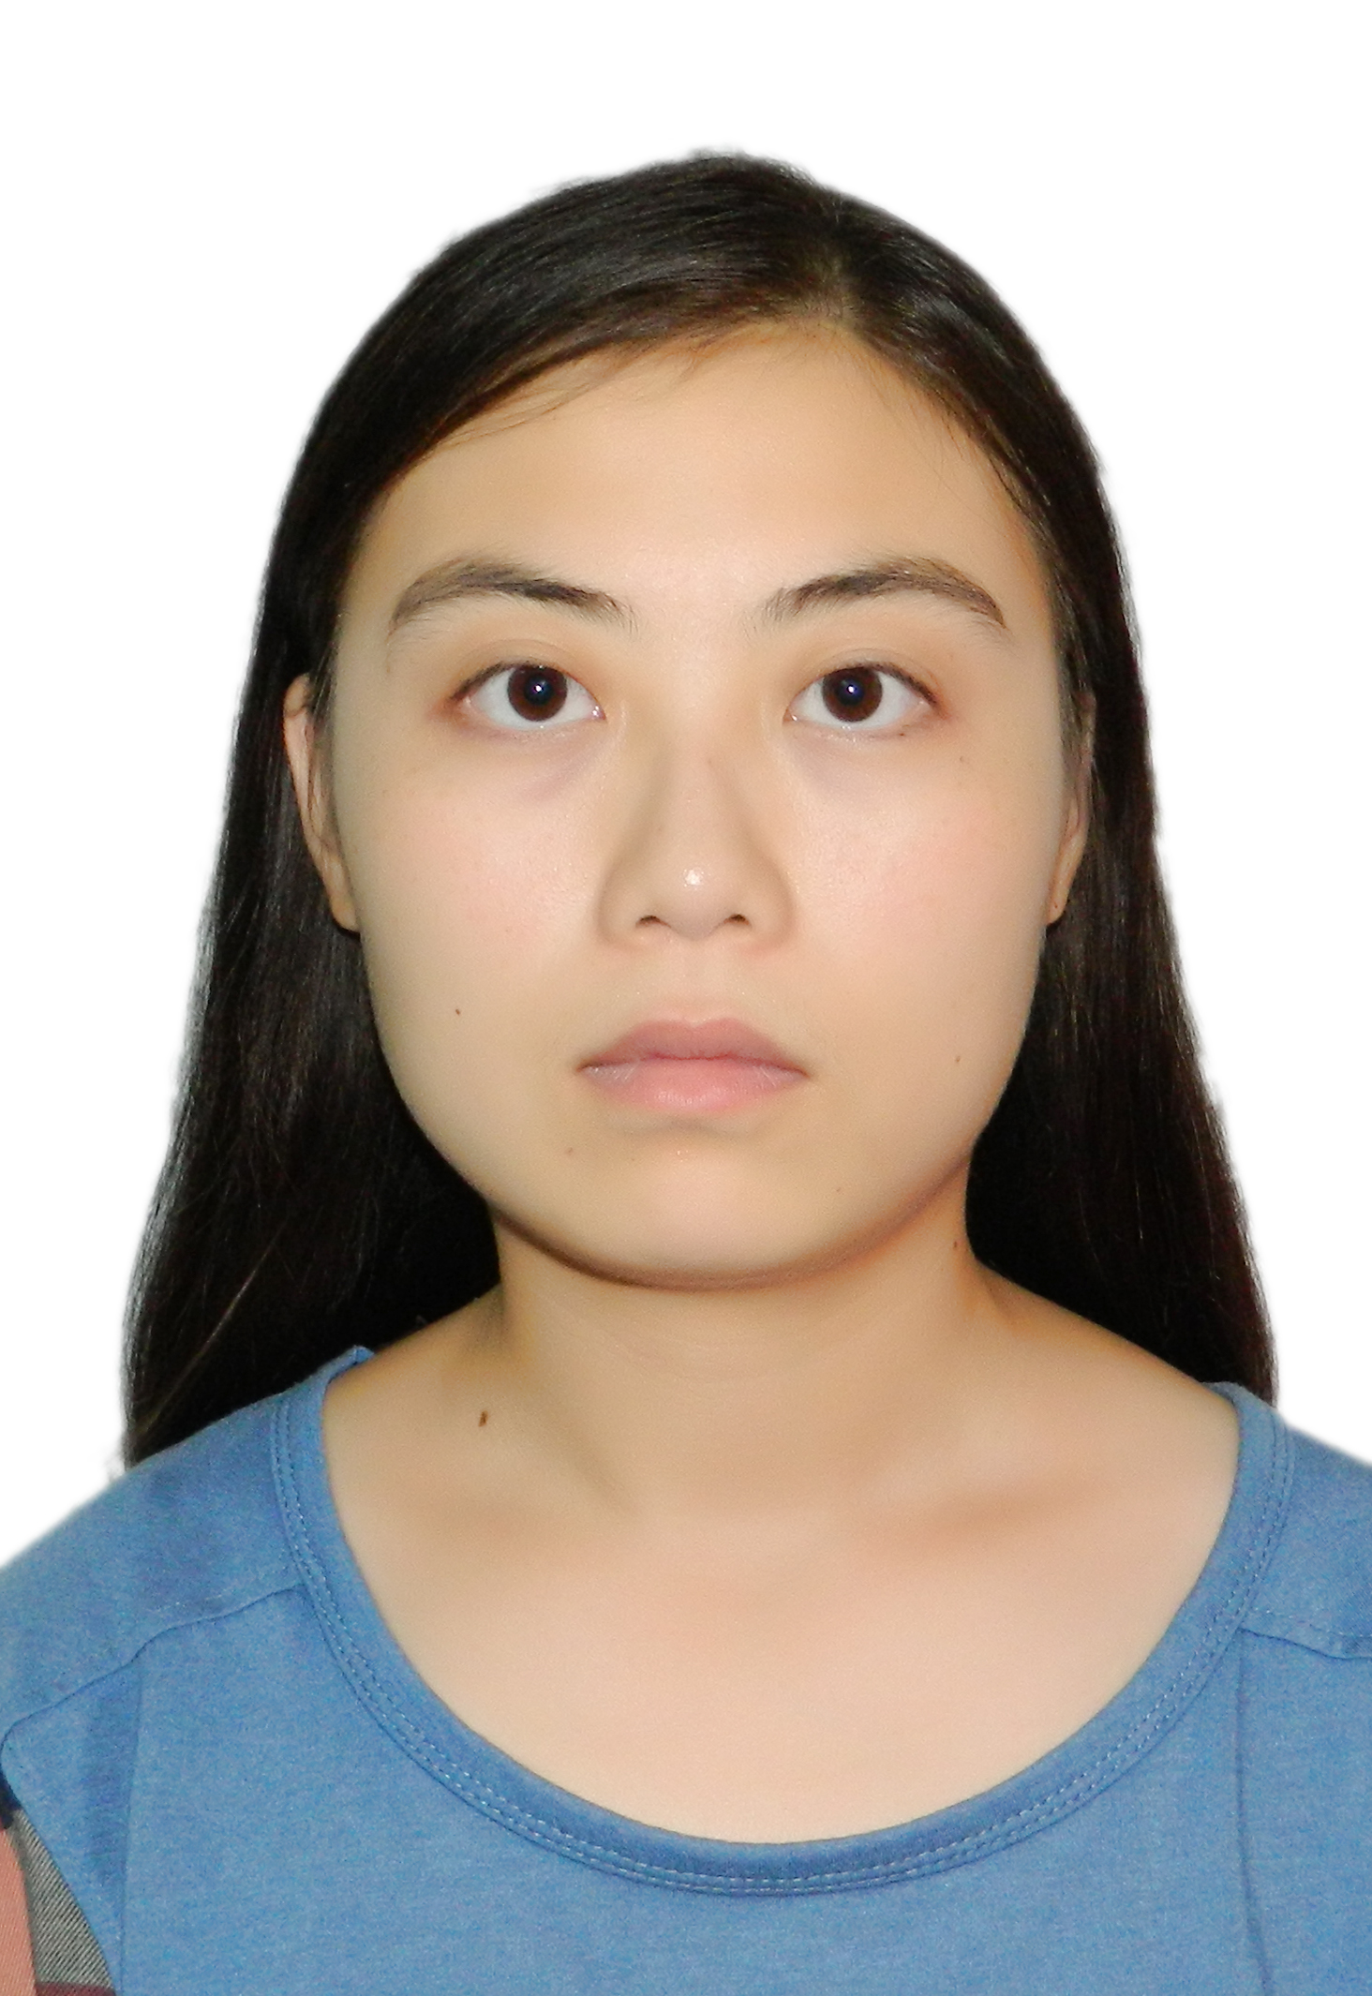

Firstly, let us define the FT,DTFT,DFT and the Z transform.
FT means continuous Fourier transform, it is mainly used for analysis of continuous, non-periodic signal. The continuous, non-periodic signal in the time domain, leads to the continuous, non-periodic signal in the frequency domain. And its formula is

DTFT means discrete-time Fourier transform, and it is used for the discrete non-periodic signal analysis. A discrete time, non-periodic signal in the time domain, leads to a frequency, continuous one in the frequency domain. And it requires the signal in the time domain must be a non-periodic one.

DFT means the discrete Fourier transform, and its formula is
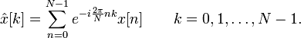

Z transform is the one that change the x [n] in the discrete time domain into the X (Z) in the frequency domain, and its formula is
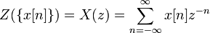.
And then let us to tell the relationship among them.
- Firstly, let us talk about the difference between FT and DTFT,DFT. FT is an analysis tool for the continuous signal spectrum, and it is result from the theoretical of Fourier series. Continuous signal in the time domain leads to the non-periodic signal in the frequency domain, and for the periodic signals and non-periodic signals in the time domain respectively result in the discrete and continuous one in the frequency domain. But there are a number of discrete signals in the world, discrete signals may be obtained through the continuous signal sampling, or there is naturally a discrete signal itself. And at this time the tools used for discrete signal spectrum analysis we will use DTFT and DFT. We can say that they are the FT for the sequence.
- Secondly, we will talk about the relationship between DTFT and DFT. DTFT is discrete -time Fourier transform , which is used for the analysis of discrete non-periodic sequence. As the continuous Fourier transform requires the continuous signal in time domain must be integrable, then when it comes to the discrete-time Fourier transform, it is must be a discrete sequence in time domain which series sum convergence in the Timeline. Since the signal is non- periodic sequence , it must contain the signals of various frequencies, so after the DTFT ,the discrete, non-periodic signal will leads to a continuous one in the frequency domain. It shows that discrete non-periodic in the time domain leads to continuous, periodic in the frequency domain. It uses DFS ( Discrete Fourier series ) this analysis tools. DFS is a discrete Fourier series .
When the discrete signal is periodic sequence , strictly speaking , discrete-time Fourier transform does not exist , because it does not satisfy that the signal sequence is absolutely series sum convergence. However, the use of DFS ( Discrete Fourier series ) analysis tool can still work it out.
And the DFT uses DFS, thus assuming the periodic and infinite of the sequence , but make a limit in the Interval during the work, to meet the characteristics of finite length , which makes the DFT with a periodicity. Furthermore, DFT is the finite number of discrete frequencies in only one period ,so it is discrete in the frequency domain .It is equivalent to turn the DTFT into a continuous spectrum ,and then sample it. And at this time ,the sampling frequency is equal to the the sequence extension N cycles.
We know that the spectrum of an N- point’s discrete Fourier transform is a continuous function based on the period of (2 * pi) , we know from the sampling theorem that sampling in the time domain ,then extension in the frequency domain .Similarly, if sampled in the frequency domain, then the time domain will have a extension . Discrete Fourier Transform (DFT) is based on this theory, sampling in the frequency domain , sampling N points in a cycle to make the signal’s spectrum to be descrete. It shows that a N -point discrete-time signals in the frequency domain can be determined by an N- point sequence in the frequency domain.
In a word, DFT is sampling the DTFT in the frequency domain and then intercept the principal value. DTFT is the FT for the sequence, and it gets continuous cycle spectrum, but DFT gets finite non-period discrete spectrum. And DFT has a fast algorithm, which is called FFT.
- Thirdly, we will talk about the relationship between DTFT and the Z transform. Z-transform is that , in Signal Processing, translate a series of real or complex discrete signal from the time domain into the frequency domain.The Z-transform translate the discrete x [n] in the time domain into X (Z) in the frequency domain. It has
.And n is integer, z is a complex variable, and its expression is .DTFT can be considered as a special case of the Z transform, Z transform is defined as 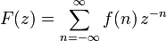, if use Z transform to translate the signal f(n) on the unit circle in the Z plane, then we have
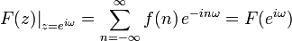, and it is the discrete-time Fourier transform of f(n). Simplely speaking, discrete-time Fourier transform equates to the Z transform on the unit circle. And the Fourier transform is a special case of the Z transform, and all the features of the Fourier transform can be obtained from the Z transform.But the require of the convergence of the DTFT is higher than the require of the convergence of the Z transform. It is said that, even though it is not accord to the convergence of DTFT, we can also get its reasonable convergence of the Z transform.
- And finally we can briefly summary the relationship between DFT and the Z transform. In my view ,I think DFT can be considered as use the Z transform after uniform sampling on the unit circle. And the former is used in the frequency Domain, the latter is used in the time domain.
Finally, all in all, no matter FT,DTFT,DFT or the Z transform, and no matter they are used in the frequency Domain or the time domain, to the signal processing, they are all indispensable, and if only we acquire the knowledge of their differences and relationships, can we skillfully doing the signal processing.

Clearly address the relationship among these transforms. Moreover, have some discussion about DFT and DFS.

85

